- Discuss the consideration / preparation should be taken when performing integration tests.
When performing integration tests, the primary focus is on how modules work together. The following preparations are essential:
- Defining Strategy: Decide whether to use a Top-Down or Bottom-Up strategy.
- Infrastructure Setup: Develop stubs (to simulate sub-modules) or drivers (to simulate main modules) to replace missing software components.
- Interface Simulation: Ensure these stubs and drivers correctly simulate the interfaces between software components.
- Priority Level: Determine the testing sequence based on module priority levels or I/O module dependencies.
- Is the test object involved had been tested well in unit test
- Is there a need to prepare stub or drivers
- Is all the required test objects (modules) ready to be tested?
- Is the test environment being already setup

- Differentiate incremental approach and non-incremental approach.
[chap 2 slide 4]
Feature | Incremental Approach | Non-Incremental Approach
Method | Combines the next module with the set of previously tested modules before testing. | Each module is tested independently, then all are combined as a whole.
Exposure | Modules receive more exposure through repeated testing as others are added. | Modules "do not see each other" until the very end of testing.
Complexity | Requires fewer total stubs or drivers (e.g., 5 total for a specific example). | Requires more work (e.g., 5 drivers AND 5 stubs for the same example).
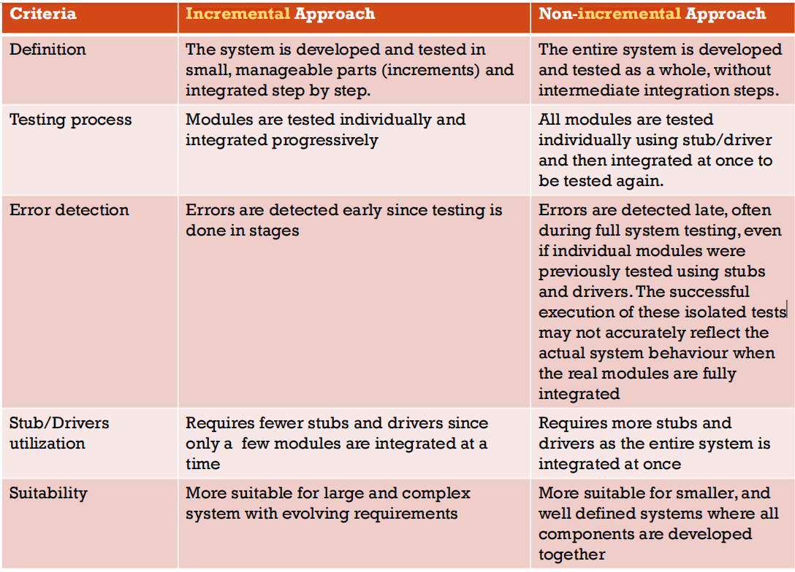

- What are the advantages and disadvantages of incremental and non-incremental approaches? Which approach is better? Justify your answer.
[chap 2 slide 11-13]
Incremental Approach
- Advantages:
  - Detects programming errors (mismatched interfaces or incorrect assumptions) earlier.
  - Debugging is easier because errors are localized to the newly added module.
  - Provides more thorough testing through increased module exposure.
  - Requires less labor to create support modules (stubs/drivers).
- Disadvantages:
  - Consumes more machine execution time.
  - Limited parallel activity compared to non-incremental.
Non-Incremental Approach
- Advantages:
  - Uses less machine time to execute the tests.
  - Enables more parallel activity among developers/testers.
- Disadvantages:
  - Requires significantly more work to create both drivers and stubs for every module.
  - Errors are found later, making them more expensive to repair.
Which is better?
The incremental approach is superior. Justification: While hardware costs (machine time) are decreasing, labor costs and the consequences of software errors are increasing. Since the incremental approach finds errors earlier, when they are cheaper to fix. Its advantages outweigh its disadvantages.
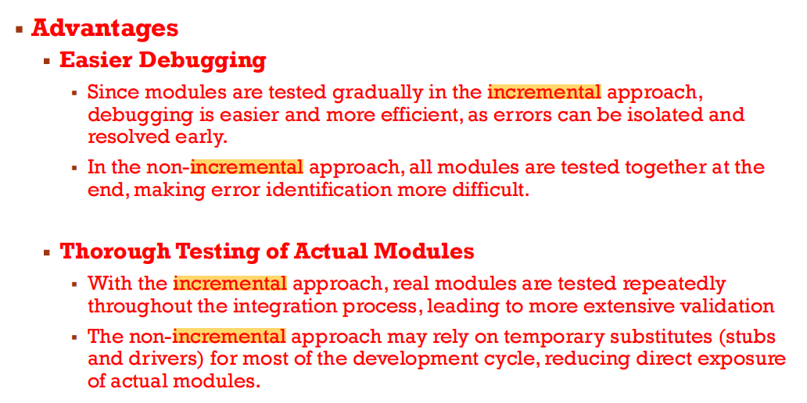
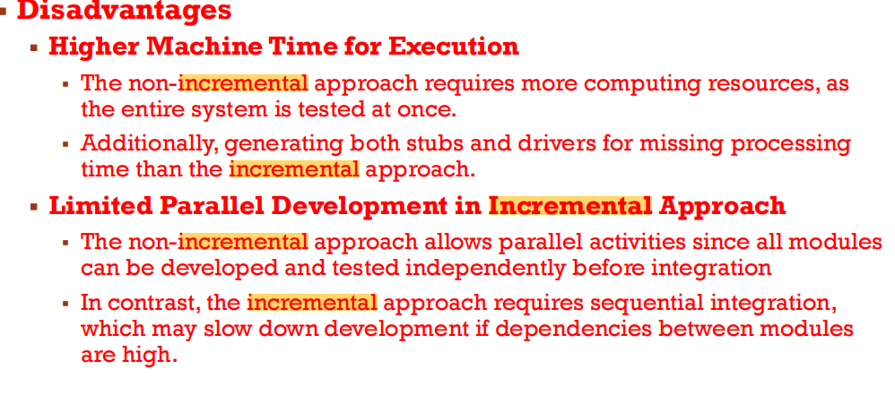
- Compare Unit Test with Integration Test.
[chap 2 slide 5-9]
Unit (Module) Testing: Focuses on individual sub-programs, classes, or procedures. It is primarily white-box oriented and verifies internal logic.
Integration Testing: Focuses on the interaction between these modules. It uses drivers and stubs to test how units work together after they have been individually verified.
Unit testing
- performed earlier in the development lifecycle, while integration testing occurs after modules have been individually verified.
- The main objective of unit testing is to ensure each module works correctly,
Integration Testing
- Focuses on the interaction between modules.
- It aims to identify discrepancies between integrated components and ensure they function correctly as a combined unit.

- In some cases, Integration Test is performed but Unit Test is ignored. Explain the reasons.
While the document emphasizes the importance of unit testing as the "initial steps", it suggests that integration testing is sometimes prioritized for the following reasons:
- Skeleton Development: In large projects, developers may concentrate on the "Critical Path" or "skeleton development" first to demonstrate a high-level program structure early.
- Morale and Demonstration: Early skeletal programs allow for demonstrations, which can boost team morale.
- Focus on Main Functions: Critical Path Testing ensures the main function of the system is covered first, which might lead to skipping granular unit tests in favor of seeing the system work as an entity

- Why is higher-order testing needed?
Higher-order testing is necessary to validate the software against broader criteria that individual module tests cannot cover:
- External Specifications: Functional testing ensures the program behaves as the end-user expects.
- Original Objectives: System testing compares the program to its original high-level goals.
- End-User Needs: Acceptance testing ensures the software meets the current needs of the users and the original contract.
- Specialized Criteria: It addresses 15 critical categories including Security, Usability, Performance, and Recovery that are vital for a production-ready system.
Higher order testing is essential in software development because it goes beyond basic unit and integration test to ensure robustness , security, usability, and reliability in real world conditions
Is essential for delivering high quality, secure, scalable, and user-friendly software. Without it, software may work in a test environment but fail in real-world usage, leading to poor performance, security risks, and user dissatisfaction.

Higher order testing is essential in software development because it goes beyond basic unit and integration testing to evaluate how well the software performs in real world conditions. While lower level tests verify that individual components work correctly, higher order test focus on the overall behavior , performance, reliability and user experience of the system
Higher-order testing—such as system testing, acceptance testing, performance testing, usability testing, security testing, and stress testing, etc.—is crucial for identifying issues that cannot be detected at the lower levels. These issues may arise only when the full system is integrated, when many users access it simultaneously, or when the software is exposed to unexpected conditions.
This type of testing is essential for ensuring that the final product is high-quality, secure, scalable, and user-friendly. It validates that the software works not only in controlled testing environments but also in real operational settings where users have diverse behaviours, devices, and usage patterns.
Without higher-order testing, there is a significant risk that the software may pass early development tests but fail after deployment. Such failures can lead to:
- Poor system performance (e.g., slow loading, crashes under heavy load)
- Security vulnerabilities that expose users or the organisation to risks
- Unintuitive or frustrating user experiences, resulting in dissatisfaction
- System breakdowns during integration with external systems or hardware
- Costly post-release fixes, which are far more expensive than early correction

- Differentiate Regression Test with Re-Test.
Regression Testing: Retesting a unit, integration, or system after modification to ensure the change did not have unintended consequences on existing behavior. It monitors the effects of change.
Re-Test (Verification): While the term "Re-test" is used colloquially for fixing an error, the document defines the verification side as the process of checking if the software matches the design and specifications at each stage
Regression test is not retest; regression test is to test the effect of a newly modified code (update,add new code) to the codes / modules around.
Retest is to perform the test again with the same test case.

Regression testing is not the same as re-testing. It is performed when modifications are made to the program code, such as adding new functions, updating processes, or removing certain features. The purpose of regression testing is to ensure that these changes do not negatively impact the system's normal operation, behavior, or other functionalities. It verifies that the system continues to function correctly after updates.
Example: After updating the login module, regression testing checks if other functionalities like profile updates and password reset are still working!
Re-testing, on the other hand, involves executing the same test cases again for a specific system function or module. It is done to confirm the correctness of previous test results, validate bug fixes, or collect test result data for analysis and reporting. Unlike regression testing, re-testing focuses only on verifying specific fixes, not checking for unintended side effects in other parts of the system. Example: If a login button issue was reported and fixed, re-testing ensures the button now works correctly.

- What is the difference between Driver and Stub?
Driver: A "dummy" module created to call the module under test; it simulates the "parent" or main module.
Stub: A "dummy" module created to be called by the module under test; it simulates a "child" or sub-module.

- Explain the relationship between the Verification and Validation in the V – Model. Identify the advantages of this model.
Relationship
The V-Model represents a parallel relationship between Verification (the development side) and Validation (the testing side).
- Verification: Ensuring the product is built correctly according to design phases.
- Validation: Ensuring the right product is built according to requirements.
Advantages
- Parallelism: Testing is planned parallel to development phases.
- Early Testing: It ensures testing happens early and continuously rather than being an afterthought.
- Requirement Validation: Emphasizes the validation of requirements at every stage
Verification (Left Side - Development Phases) which ensures the product is built correctly before implementation while Validation (Right Side - Testing Phases) which ensures the product meets user expectations.
Advantages:
Early defect detection - Testing starts from the beginning, reducing late-stage bugs.
Structured Approach - Every phase has a corresponding test, ensuring complete coverage.
Better documentation - Clear mapping between development and testing phases.
Reduces risk - Continuous validation ensures the final product meets expectations

- Give an example of an artifact that to be tested/reviewed for each stage in a V – Model. Discuss what the quality attributes are (e.g. Correctness, Consistency, Reliability, Security ...etc.) to be tested for the artifacts.
Stage | Artifact to Review/Test | Quality Attributes Tested
Requirements | Requirements Document | Correctness: Does it meet user needs?
Objectives | Program Objectives | Consistency: Are the goals aligned with requirements?
External Spec | External Specifications | Security/Usability: Are interfaces safe and user-friendly?
System Design | Architecture/System Design | Reliability/Recovery: Can it handle failures?
Module Spec | Interface Specifications | Consistency: Do module interfaces match?
Coding | Source Code | Correctness: Does logic follow the design?

SRS - Requirement Analysis. Correctness, Consistency, Testability.
SDD - Architecture Design. Correctness, Consistency, Maintainability.
Coding - Consistency, Maintainability

